# fFlight simulator V3.x

## PC preparation for developer

Install:

* python version 3.11.9
* qt creator 18.0.0 community Edition
* install PyCharm 2025.2.4

## For user and developers

### x-plane

* installation from [X-Plane | The world’s most advanced flight simulator.](https://www.x-plane.com/)

|  |
| --- |
| check if streaming is running on x-plane (assuming x-plane is running on the same pc)  Adapt IP address, if x-plane is NOT on same computer |
|  |

MSFS2024

* Install MSFS2024 (via steam)
* Start -> Settings -> General -> Advanced options -> enable developer mode
* On top screen menu insall SDK  
  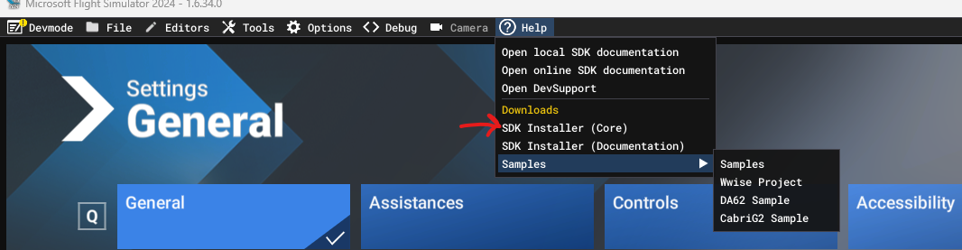  
  You should have than :  
  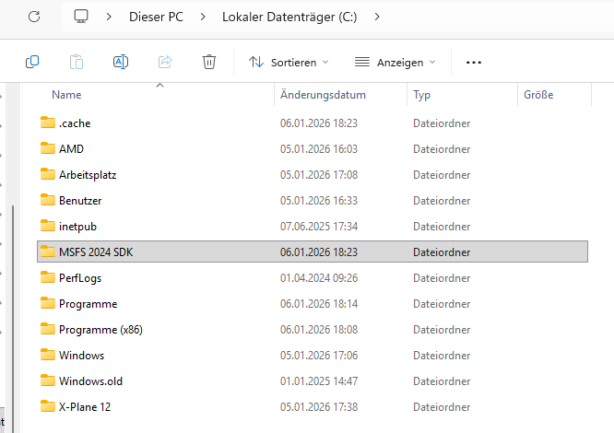
* Install Mobiflight <https://www.mobiflight.com/>, this enables Telemetry handling  
  -> while installation chose WASM module for MSFS2024 as well
* Check in MSFS2024 if WASM is enabled  
  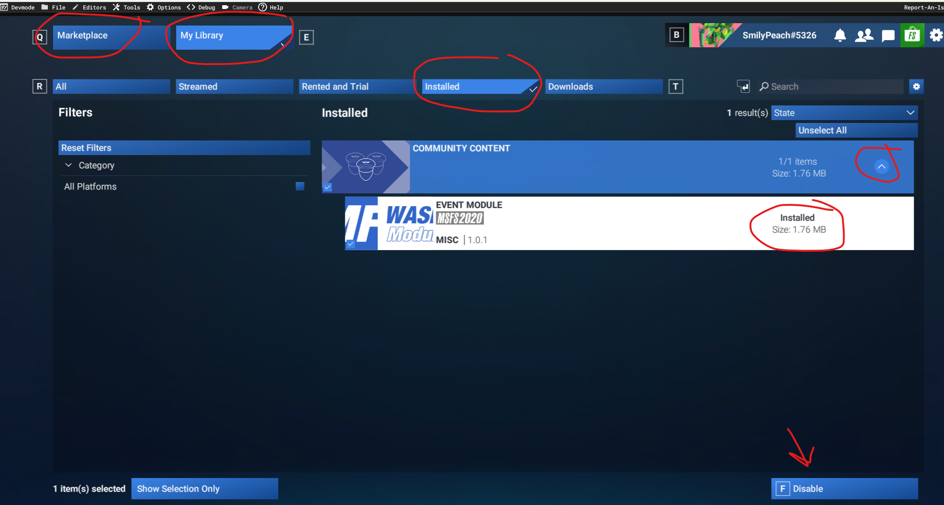

MotionCompensation

* Install openXR MotionCompensation [Releases · BuzzteeBear/OpenXR-MotionCompensation](https://github.com/BuzzteeBear/OpenXR-MotionCompensation/releases)
* Adapt settings:

[startup]

physical_enabled = 0

…

[tracker]

type = yaw

side = none

role = none

…

Add at the end of the file

[motion_source]

source_type = mmf

mmf_name = OxrMcInput

mmf_format = euler_deg

**🏗️ High‑Level Architecture**

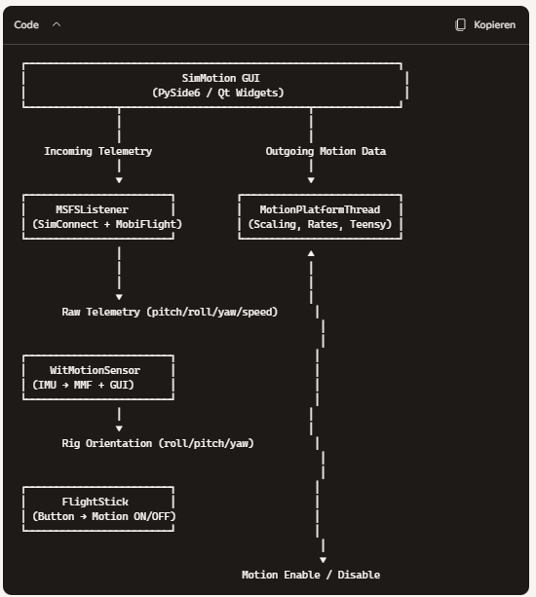

# SimMotion Software

## MSFSListener

**Thread type:** QThread **Purpose:** Fetch raw telemetry from MSFS at high frequency **Tech:** SimConnect + MobiFlightVariableRequests

**Outputs (via Qt signal):**

* pitch (deg)
* roll (deg)
* yaw (deg true)
* airspeed (knots)
* frame_rate (Hz)
* timestamp

**Key features:**

* Auto‑reconnect
* Graceful fallback (zeros when telemetry missing)
* High‑frequency polling (50 Hz)
* No scaling, no filtering → pure raw data

## MotionPlatformThread

**Thread type:** QThread **Purpose:** Convert raw telemetry into motion commands and send to Teensy

**Inputs:**

* Raw telemetry from MSFSListener
* Scaling factors from GUI (SimMotion)
* Motion enable/disable toggle

**Responsibilities:**

* Compute Euler rates (pitch_rate, roll_rate, yaw_rate)
* Apply scaling factors
* Apply deminute curves based on airspeed
* Format Teensy packet:

|  |
| --- |
| X;pitch_angle;pitch_rate;roll_angle;roll_rate;yaw_angle;yaw_rate;airspeed\n |

* Send serial data to Teensy
* Emit outgoing telemetry for GUI

## WitMotionSensor

**Thread type:** Worker thread **Purpose:** Read IMU data and provide rig orientation

**Outputs:**

* roll_adj
* pitch_adj
* yaw_adj

**Responsibilities:**

* Read IMU via serial
* Apply calibration offsets
* Write orientation to MMF (for VR motion compensation)
* Update GUI labels asynchronously

## FlightStick

Purpose: Hardware toggle for motion enable/disable

Responsibilities:

Detect button press (button 7)

Emit Qt signal to toggle motion platform

## SimMotion (Main GUI Application)

**Purpose:** Orchestrates all components **Responsibilities:**

* Start/stop all threads
* Manage stop_event for clean shutdown
* Provide scaling factors to MotionPlatformThread
* Display incoming/outgoing telemetry
* Display IMU orientation
* Provide user controls (connect, motion toggle, quit)
* Handle errors and status messages

## **Data Flow Summary**

### **Telemetry Path**

|  |
| --- |
| MSFS → SimConnect → MobiFlight → MSFSListener → Qt Signal → MotionPlatformThread → Teensy |

### IMU Path

|  |
| --- |
| WitMotion IMU → Serial → WitMotionSensor → MMF + GUI |

### Motion Toggle Path

|  |
| --- |
| FlightStick → Qt Signal → SimMotion → MotionPlatformThread |

### GUI Update Path

|  |
| --- |
| MSFSListener → SimMotion GUI  MotionPlatformThread → SimMotion GUI  WitMotionSensor → SimMotion GUI |

## Threading Model

| **Component** | **Thread Type** | **Communication Method** |
| --- | --- | --- |
| MSFSListener | QThread | Qt Signal (dict) |
| MotionPlatformThread | QThread | Qt Signal (dict) |
| WitMotionSensor | Worker | Direct callback + Qt |
| FlightStick | Internal | Qt Signal |
| GUI (SimMotion) | Main Thread | Qt event loop |

## **Separation of Concerns**

| **Layer** | **Responsibility** |
| --- | --- |
| **SimMotion** | Orchestration, GUI, configuration |
| **MSFSListener** | Raw telemetry acquisition |
| **MotionPlatformThread** | Motion cueing logic + Teensy output |
| **WitMotionSensor** | Rig orientation + MMF |
| **FlightStick** | Hardware toggle |

|  |  |
| --- | --- |
|  |  |

Installation

Install x-plane 12 or MSFS2024

Install simHub [SimHub | Pro Sim Racing](https://prosimracingteam.com/simhub/)

# HW

## Motors

See copilot_drive_chain_assessment.docx

|  |  |
| --- | --- |
|  |  |
|  |  |

Changes 24.1.2026

24VDC

Microstep from 40000 to 4000

# Electronic

|  |  |
| --- | --- |
|  |  |
|  |  |
|  |  |

# Firmware

Protocol concept

X;timestamp;pitch;pitch_rate;roll;roll_rate;yaw;yaw_rate;air_speed

|  |  |  |  |  |  |  |  |  |  |  |  |  |  |  |  |  |  |  |  |  |
| --- | --- | --- | --- | --- | --- | --- | --- | --- | --- | --- | --- | --- | --- | --- | --- | --- | --- | --- | --- | --- |
| | **Field** | **Purpose** | | --- | --- | | X | Message type or header (x plane closed loop) | | timestamp | Optional for Teensy unless you need sync or logging | | pitch | Degrees (float), aircraft nose up/down | | pitch_rate | Degrees/sec (float), angular velocity | | roll | Degrees (float), aircraft bank | | roll_rate | Degrees/sec (float), angular velocity | | yaw | Degrees (float), heading | | yaw_rate | Degrees/sec (float), angular velocity | | air_speed | Knots or m/s (float), for dynamic gain adjustment | |

Example

|  |
| --- |
| X;ts=1698945600.123;mode=POS;pitch=12.5;pitch_rate=3.2;roll=-5.1;roll_rate=-1.8;yaw=90.0;yaw_rate=0.0;airspeed=120.3 |

Available commands:

X;... -> live motion stream from X-Plane

H; -> homes pitch and roll to center

E; -> prints current pitch, roll, yaw positions

P;[angle] -> move pitch to [angle] (±30° limit)

R;[angle] -> move roll to [angle] (±30° limit)

Y;[angle] -> move yaw to [angle] (step count only)

?; -> prints this help menu

# Simulator preparations

## x-plane preparation

|  |  |
| --- | --- |
|  | 12 Btn 9: Toggle enabling of VR hardware  11 Btn 8: Hold brake left   *🡪 hack to reload motion compensation of VR*  7 Btn 4: Reset VR View  ­­­­­­_______________________________________________  10 Btn 7: Reset flight to most recent start  9 Btn 6: Toggle brakes max effort  *🡪 hack to set motion platform on and off*  8 Btn 5: Toggle simulation paused state  ­­­­­­_______________________________________________  15 Do nothing |

Bild – usb controller

10 – 8

9 – 7 toggle platform

8 – 6

12-10

11-9 toggle motion compensation

7-5

15-13

Graphic setting for AMD Ryzen 9 9950X3D with AMD Radeon RX 9070 XT

## Msfs – graphic tests

|  |  |  |  |
| --- | --- | --- | --- |
| Fix fps | Max frame rate  Rendering scale 140 |  |  |

Best settings for msfs2024

VR

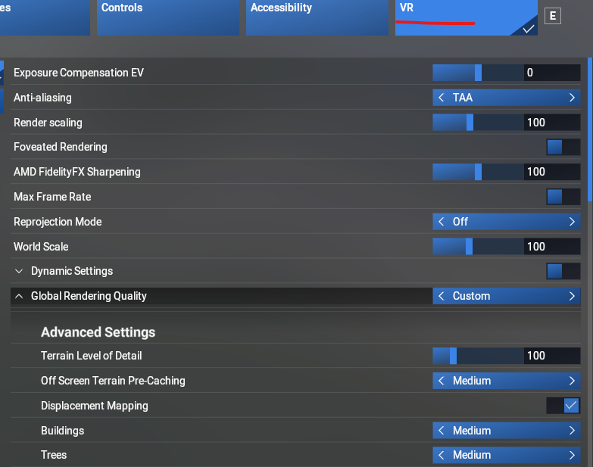

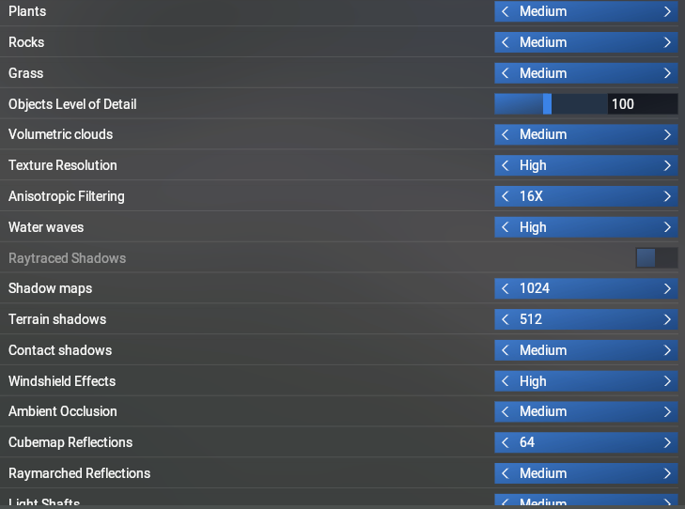

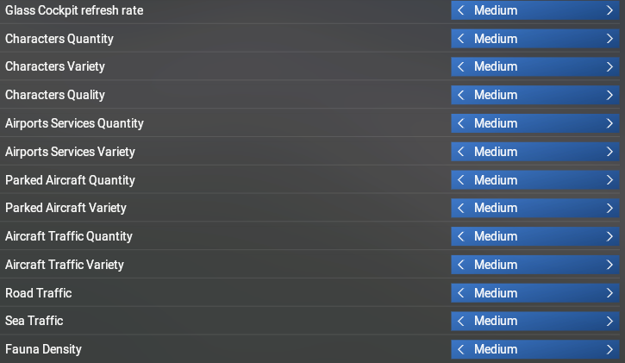

Quest

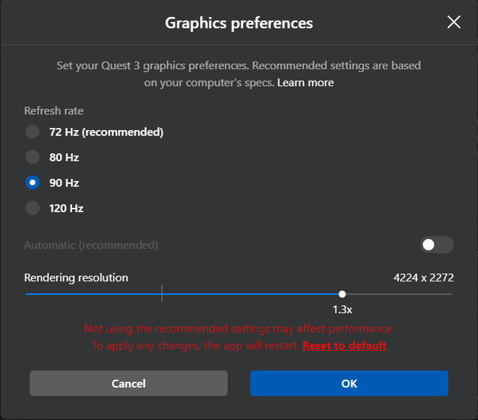

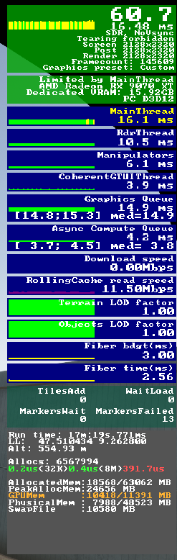

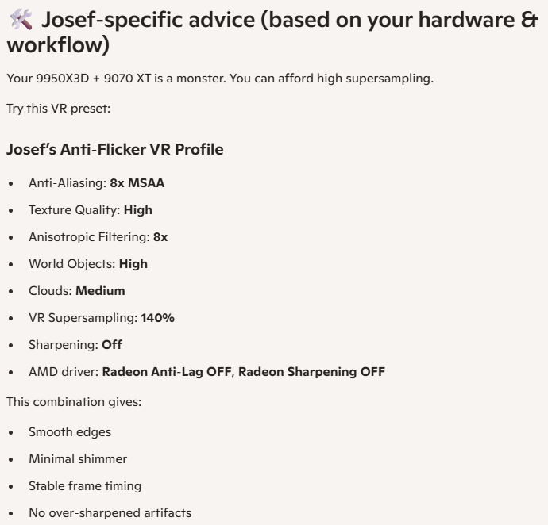

Last settings 12.1.2026

|  |
| --- |
|  |
| Quest |

# OpenXR Motion compensation

*9.11.2025*

Download OpenXR-MotionCompensation from

[Releases · BuzzteeBear/OpenXR-MotionCompensation](https://github.com/BuzzteeBear/OpenXR-MotionCompensation/releases)

Make a copy of

"C:\Users\[ YOUR_USERNAME]\AppData\Local\OpenXR-MotionCompensation\OpenXR-MotionCompensation.ini"

To

"C:\Users\[YOUR_USERNAME]\AppData\Local\OpenXR-MotionCompensation\X-Plane.ini"

Adapt the section in X-Plane.ini

|  |
| --- |
| **[startup]**  enabled = 1  auto_activate = 1  auto_activate_delay = 0  physical_enabled = 0 |

add this sections at the end:

|  |
| --- |
| **[axes]**  compensate_roll = true  compensate_pitch = false  compensate_yaw = false |

Restart VR link (e.g. meta quest link 🡪 Settings 🡪 Beta 🡪 Restart Meta Quest Link)

Start x-plane 🡪 start a flight 🡪 start VR mode and test motion compensation with

openxr_injection_test.py

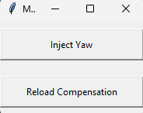

Click Inject Yaw 🡪 this should turn you view 360° around yaw

# Send motion platform status to cockpit

Install FlyWithLua from here  
[FlyWithLua NG+ (Next Generation Plus) Edition for X-Plane 12 (Win, Lin, Mac) - Utilities - X-Plane.Org Forum](https://forums.x-plane.org/files/file/82888-flywithlua-ng-next-generation-plus-edition-for-x-plane-12-win-lin-mac/)

(mainly copy folder FlyWithLua to C:\X-Plane 12\Resources\plugins)

create a file SimMotion.lua and SimMotionStatus.txt

SimMotion.lua example

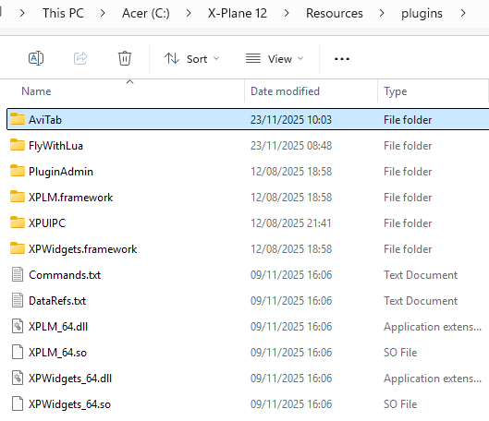

# Addon scenery

Requires

[OpenSceneryX – Kostenlose Szenerieobjekte für X-Plane®](https://www.opensceneryx.com/)

Than download scenery from store.x-plane.com

|  |
| --- |
| **Switzerland Photorealistic XP Installation**  Extract all folders (total number is 53) into xplane Custom scenery folder.  look for a file called: scenery.packs.ini file (located inside xplane custom scenery folder).  Copy and paste the follow lines into scenery.packs.ini as they are: MAKE SURE airports or cityscapes scenery are above the Switzerland Ortho scenery including default Global Airports: See example below:  SCENERY_PACK Custom Scenery/MY AIRPORT ADDON/ SCENERY_PACK *GLOBAL_AIRPORTS* SCENERY_PACK Custom Scenery/Switzerland_Ortho_Forests/ SCENERY_PACK Custom Scenery/Switzerland_Ortho_Forests_Exclude/ SCENERY_PACK Custom Scenery/switzerland_ortho_B_05/ SCENERY_PACK Custom Scenery/switzerland_ortho_B_06/ SCENERY_PACK Custom Scenery/switzerland_ortho_B_07/ SCENERY_PACK Custom Scenery/switzerland_ortho_B_08/ SCENERY_PACK Custom Scenery/switzerland_ortho_B_09/ SCENERY_PACK Custom Scenery/switzerland_ortho_B_10/ SCENERY_PACK Custom Scenery/switzerland_ortho_B_11/ SCENERY_PACK Custom Scenery/switzerland_ortho_B_12/ SCENERY_PACK Custom Scenery/switzerland_ortho_C_01/ SCENERY_PACK Custom Scenery/switzerland_ortho_C_02/ SCENERY_PACK Custom Scenery/switzerland_ortho_C_03/ SCENERY_PACK Custom Scenery/switzerland_ortho_C_04/ SCENERY_PACK Custom Scenery/switzerland_ortho_C_05/ SCENERY_PACK Custom Scenery/switzerland_ortho_C_06/ SCENERY_PACK Custom Scenery/switzerland_ortho_C_07/ SCENERY_PACK Custom Scenery/switzerland_ortho_C_08/ SCENERY_PACK Custom Scenery/switzerland_ortho_C_09/ SCENERY_PACK Custom Scenery/switzerland_ortho_C_10/ SCENERY_PACK Custom Scenery/switzerland_ortho_C_11/ SCENERY_PACK Custom Scenery/switzerland_ortho_C_12/ SCENERY_PACK Custom Scenery/switzerland_ortho_B_02/ SCENERY_PACK Custom Scenery/switzerland_ortho_B_03/ SCENERY_PACK Custom Scenery/switzerland_ortho_B_04/ SCENERY_PACK Custom Scenery/switzerland_ortho_A_07/ SCENERY_PACK Custom Scenery/switzerland_ortho_A_08/ SCENERY_PACK Custom Scenery/switzerland_ortho_A_09/ SCENERY_PACK Custom Scenery/switzerland_ortho_A_10/ SCENERY_PACK Custom Scenery/switzerland_ortho_A_05/ SCENERY_PACK Custom Scenery/switzerland_ortho_A_06/ SCENERY_PACK Custom Scenery/switzerland_ortho_A_04/ SCENERY_PACK Custom Scenery/switzerland_ortho_A_03/ SCENERY_PACK Custom Scenery/switzerland_ortho_D_02/ SCENERY_PACK Custom Scenery/switzerland_ortho_D_03/ SCENERY_PACK Custom Scenery/switzerland_ortho_D_04/ SCENERY_PACK Custom Scenery/switzerland_ortho_D_05/ SCENERY_PACK Custom Scenery/switzerland_ortho_D_06/ SCENERY_PACK Custom Scenery/switzerland_ortho_D_07/ SCENERY_PACK Custom Scenery/switzerland_ortho_D_08/ SCENERY_PACK Custom Scenery/switzerland_ortho_D_09/ SCENERY_PACK Custom Scenery/switzerland_ortho_D_10/ SCENERY_PACK Custom Scenery/switzerland_ortho_D_11/ SCENERY_PACK Custom Scenery/switzerland_ortho_D_12/ SCENERY_PACK Custom Scenery/switzerland_ortho_E_01/ SCENERY_PACK Custom Scenery/switzerland_ortho_E_03/ SCENERY_PACK Custom Scenery/switzerland_ortho_E_04/ SCENERY_PACK Custom Scenery/switzerland_ortho_E_05/ SCENERY_PACK Custom Scenery/switzerland_ortho_E_06/ SCENERY_PACK Custom Scenery/switzerland_ortho_E_07/ SCENERY_PACK Custom Scenery/switzerland_ortho_E_08/ SCENERY_PACK Custom Scenery/switzerland_ortho_E_09/ SCENERY_PACK Custom Scenery/switzerland_ortho_D_01/  end of install |

New PC

Windows

[Windows 11 Pro | Für professionelle Nutzer | SwissSoftware24](https://swisssoftware24.ch/products/windows-11-pro/)

PC

[Captiva R89-504 - kaufen bei Galaxus](https://www.galaxus.ch/de/s1/product/captiva-r89-504-2000-gb-64-gb-amd-ryzen-7-7800x3d-geforce-rtx-5070-ti-pc-54833046)

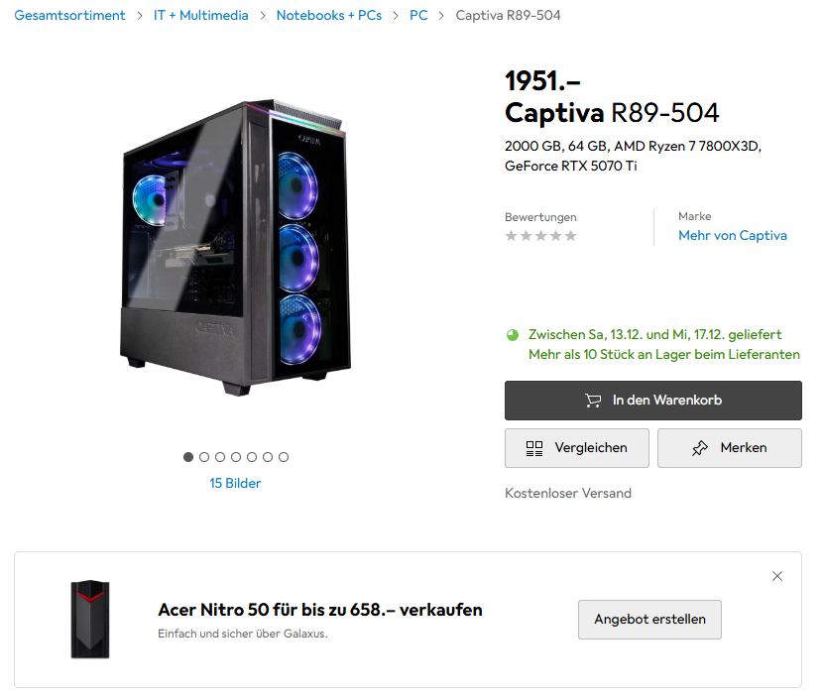

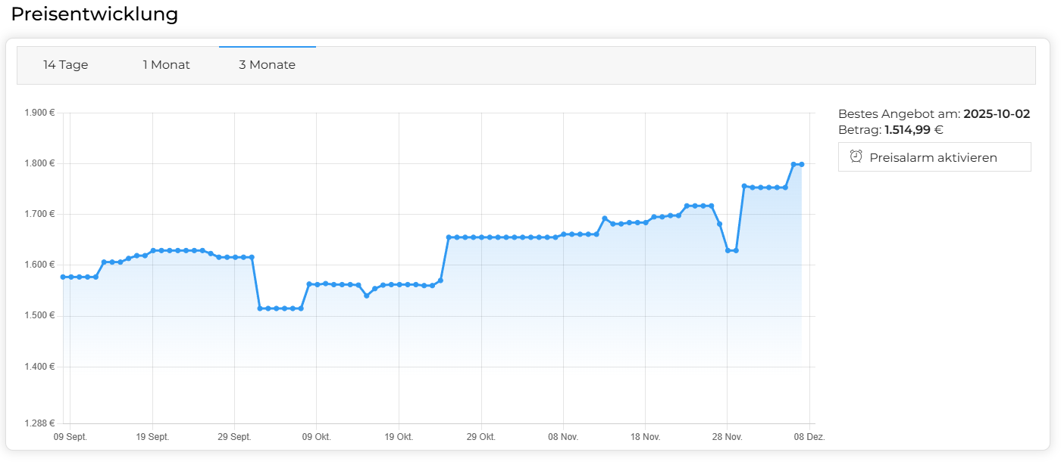

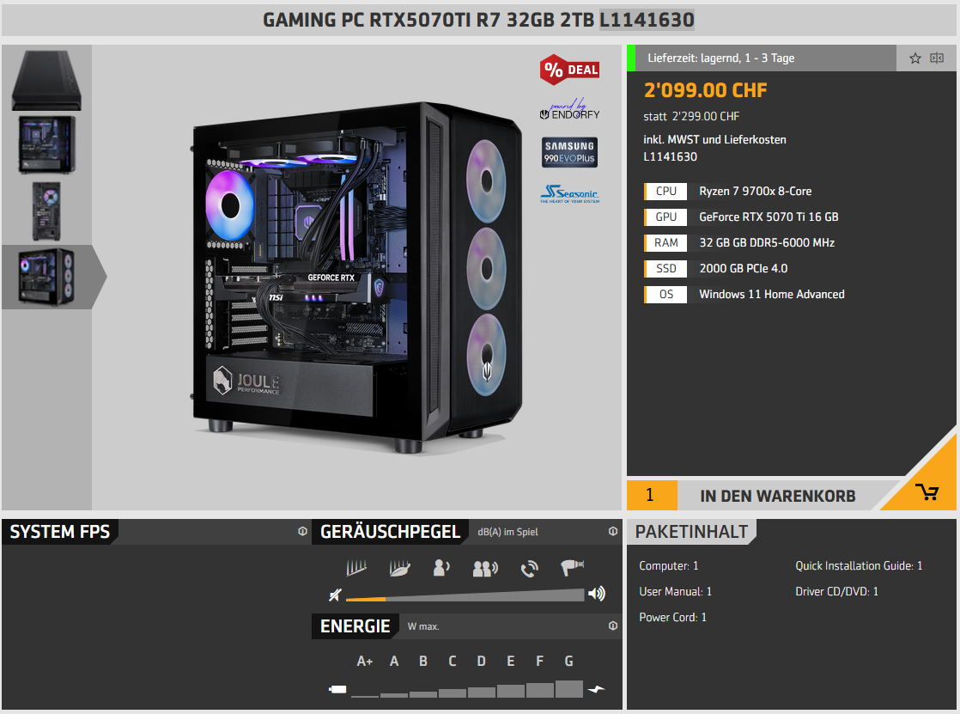

Meta quest 3

Troubles  
no connection possible

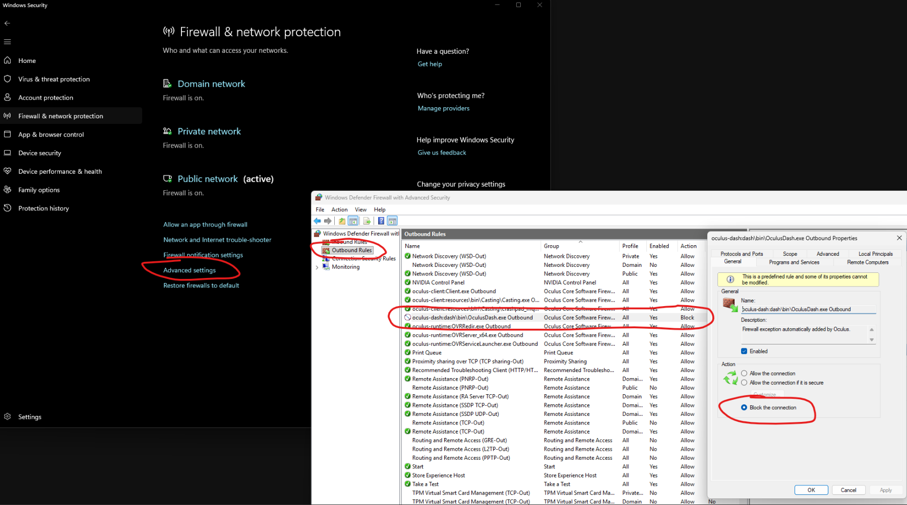

[Horizon link not working | Meta Community Forums - 1362707](https://communityforums.atmeta.com/discussions/PairingConnection/horizon-link-not-working/1362707)

And

[Horizon link not working | Meta Community Forums - 1362707](https://communityforums.atmeta.com/discussions/PairingConnection/horizon-link-not-working/1362707/replies/1362966)

VR optimisation

[VR & FPS {SOLVED] - VR in X-Plane 12 - X-Plane.Org Forum](https://forums.x-plane.org/forums/topic/310791-vr-fps-solved/)

|  |  |
| --- | --- |
| Original |  |